# Web Technologies

## Assignment no 1

### Question no 1:

Code

Output

### Question no 2:

Code

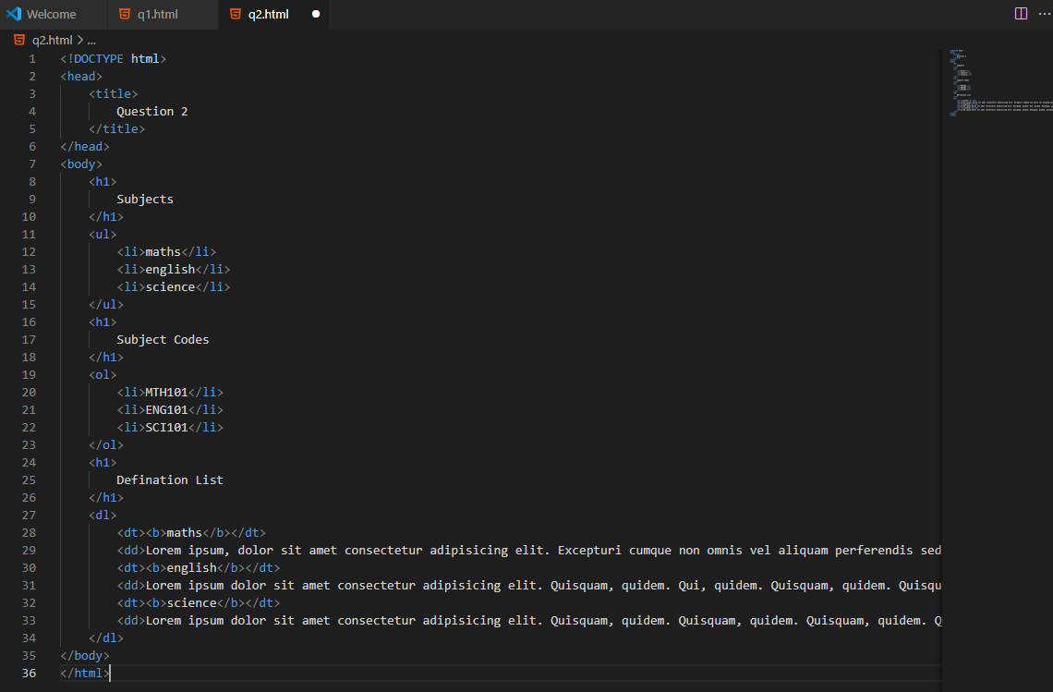

Output

### Question no 3:

Code

Output

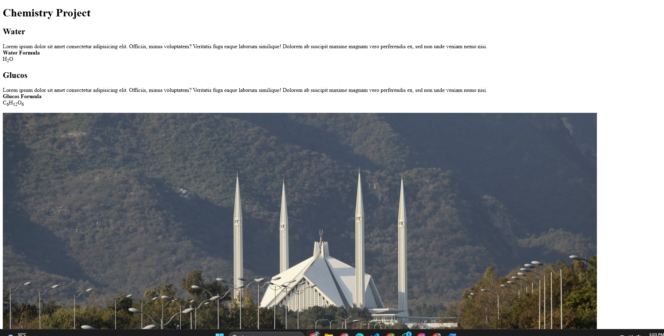

### Question No 4:

Code

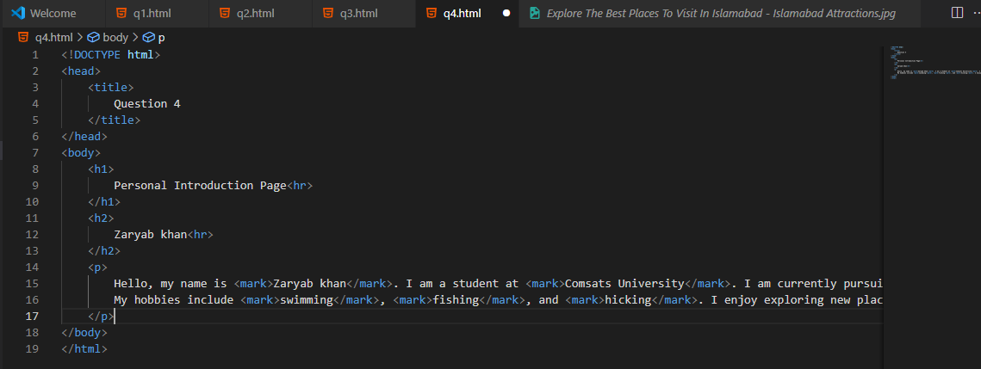

Output

### Question No 5

Code

Output

### Question No 6:

Code

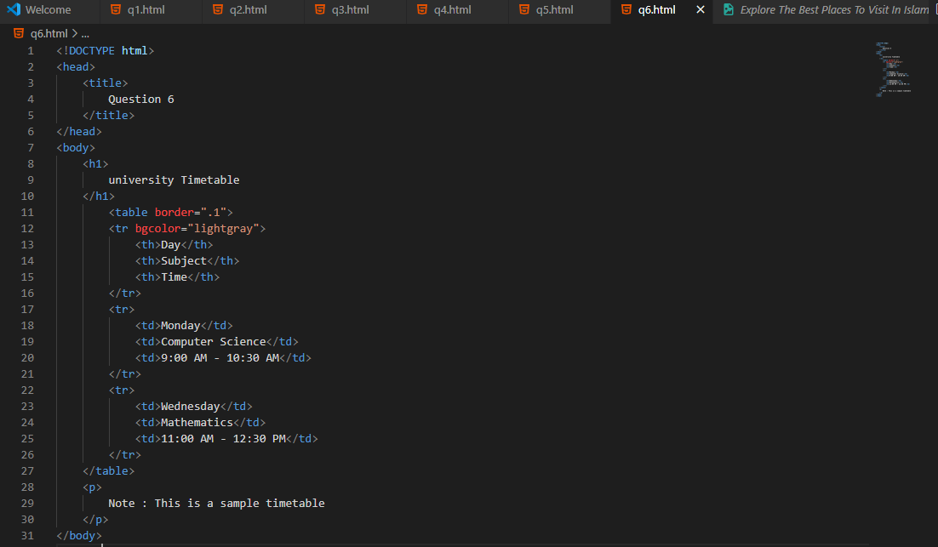

Output

